1. **RNF Employee Masterlist**

*In RNF Employee Masterlist, you will input the Department, Area of Assignment, Regio, and other details when the employee is hired to view the report.

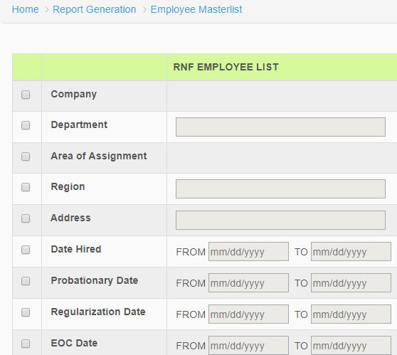

Figure 1.0

1. **VIP Employee Masterlist**

*In VIP Employee Masterlist, you will input the blank area below and select when the employee got regular.

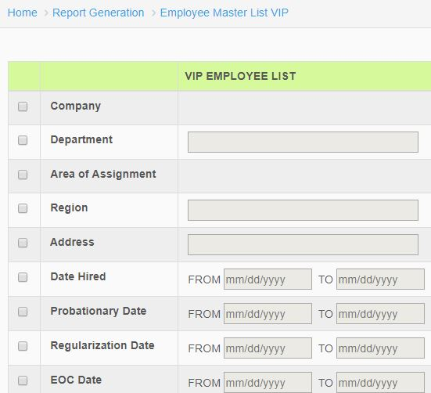

*Figure 2.0*

1. **List of Active Employees**

*In List of Active Employees, select the output and click process button to generate the report.

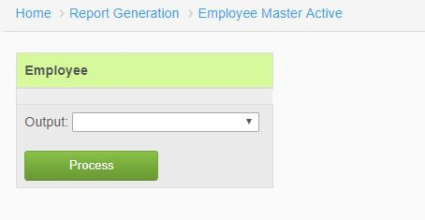

*Figure 3.0*

1. **Tardy**

*In Tardy, the user will select the company, location, date from and date to when then the employee get late or delayed. Click process button to generate reports.

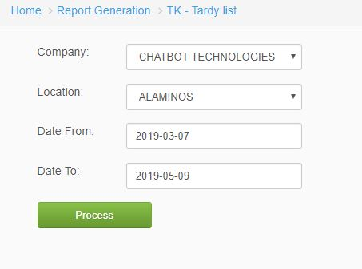

*Figure 4.0*

1. **Employee for Regularization**

*In Employee for Regularization, the user will select the month, year, and company to view report. Click Process button to generate reports.

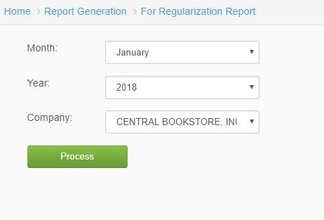

*Figure 5.0*

1. **List of Separated Employees**

*In List of Separated Employees, Input the start and end date of the employee and click process button to generate report.

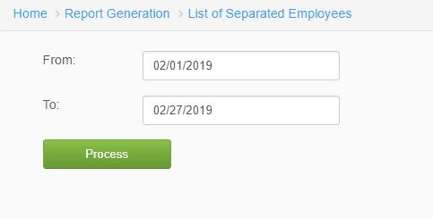

*Figure 6.0*