To Access SPGC Employee Electronic Purchase (Admin)
1. Open your Internet Browser (preferably Google Chrome)
2. Use the Web Address Location Featured Below:
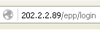
Login:
- After entering the Web Address Location you will be redirected to the Login screen
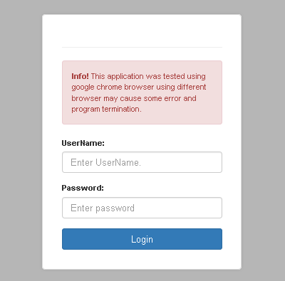

Main View:
- When you enter the correct username and password the system will redirect you to the main view, here, you can see the menu according to your access level. you can see here the version no., transaction and maintenance module, and the currently log user.
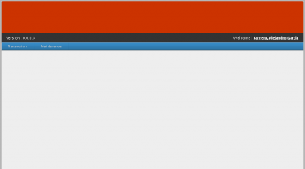

ORDER

Employee Order

Navigating to Employee Order
* In the navigation bar, there is one tab named Order. Hover your mouse over it, a sub- menu will appear. Click Employee Order.

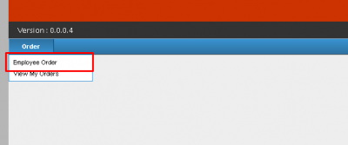

*Now a Employee Ordering Form will appear. It contains, Store, Employee, Credit Limit, Available Balance.

STEP 1:
*Click on the Store Combo box, Choose Dinorado.
After choosing Dinorado; Item, Qty, Price, and Total Amount will appear.
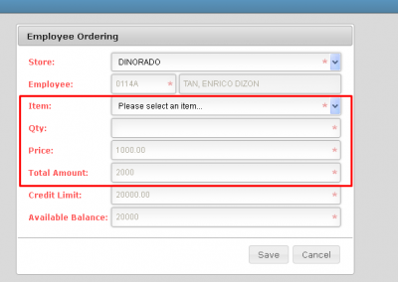
STEP 2:
*Choose desired Item. in Item Combo box.
Willy Dinorado Rice 5Kg price is 200, while, Willy Dinorado Rice 25kg Price is 1000.
STEP 3:
*Now enter quantity of your Item.
it will also be multiplied to the price, You will see the Total price of your transaction, on Total Amount textbox.
STEP 4:
Now press Save.
Your transaction will be forwarded to HR, HR will now be responsible for your Transaction.

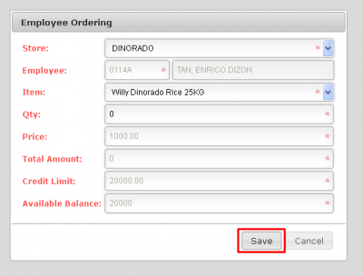
Other Information
*If your Total amount will exceed your Credit Limit then, A message box will be containing that you cant continue further because Total Amount exceeded your Credit limit.
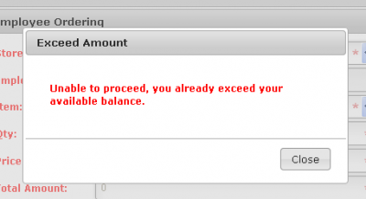

Process Order
Navigating to Process Order
* In the navigation bar, there is one tab named Order. Hover your mouse over it, a sub- menu will appear. Click Process Order.
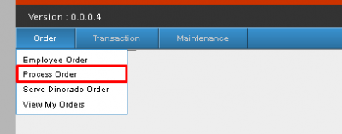
* Now an Employee Ordering Form will appear.
STEP 1:
Input date in From, To, and you must also input the release date. Now press Process.
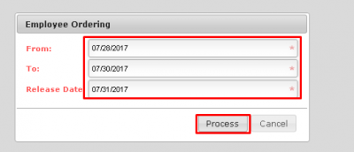

STEP 2:
* After pressing Process, A window Pop-up will appear.
There is the Details of the Order; The Reference no., The Release Date, Date/Time, Processed by, and the other important Details of the Order. (Take note of the Reference No.)
In the Window pop-up you may also download or print the results on the upper part of the window.

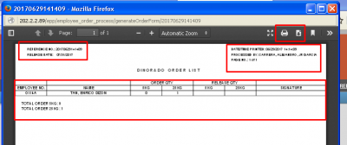

Reprint Order
Navigating to Reprint Order
*Hover your mouse over the Order tab, a sub-menu will appear. Click Reprint Order a Reprint Order form will appear. You may now enter the required information.
STEP 1:
Select a Location
You can select a location by using the location Combo box.
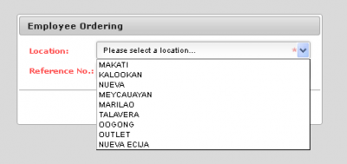
STEP 2:
Select a Reference no.
Reference Numbers will appear on its combo box based on the location you selected.
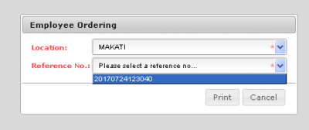
STEP 3:
Press Print.

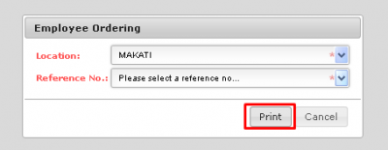
Other Information
* After pressing print a window pop-up will appear; In there are the results, you may print or download the form.
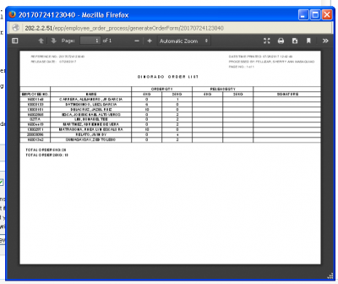

Serve Dinorado Order
Navigating to Serve Dinorado Order
* In the navigation bar, there is one tab named Order. Hover your mouse over it, a sub- menu will appear. Click Serve Dinorado Order.
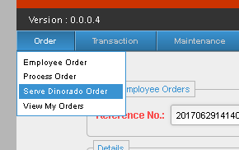
STEP 1:
Enter Reference No.
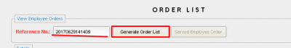
* Now the Results will now appear below, within the Served Employee Order,
STEP 2:
click a certain order, now enter the right Served item of the Employee, then press Enter.
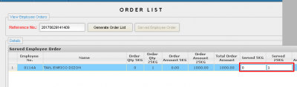

* Now After pressing Enter, The Served Employee Order button will now be Enabled,
STEP 3:
click on the Order, then press the Served Employee Order button.
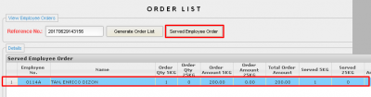

View My Orders
Navigating to View My Orders
* In the navigation bar, there is one tab named Order. Hover your mouse over it, a sub - menu will appear. Click View My Orders.
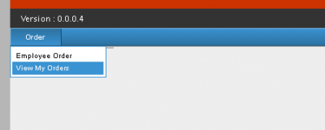
*Order list Module will appear. You must now enter the Date range of your Transactions you want to search, Now Enter Date from, and Date to. Then press View Orders. Your search will appear below, within Served Employee Order

STEP 1:
Enter Date From.
STEP 2:
Enter Date To
STEP 3:
Press View Orders.
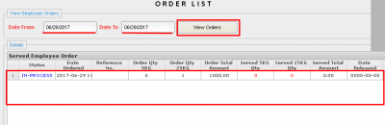
View All Orders
Navigating to View all Orders
* In the navigation bar, there is one tab named Order. Hover your mouse over it, a sub - menu will appear. Click View All Orders.

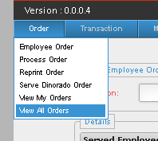
STEP 1:
Select Desired Location.
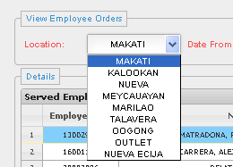
STEP 2:
Select Date From
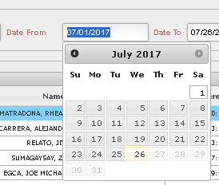

STEP 3:
Select Date To
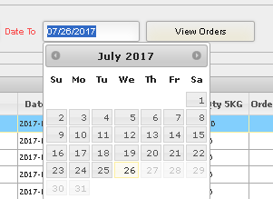
STEP 4:
Press View Orders.
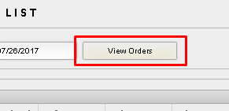

* You will now see all the orders in that certain date range.

TRANSACTION
Transaction Module:
- In the Transaction Module, this is where the E.P.P. transactions will be processed.
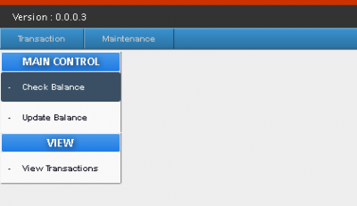
-When you hover your mouse over the transaction tab, a sub-menu will appear beneath, click the balance check.
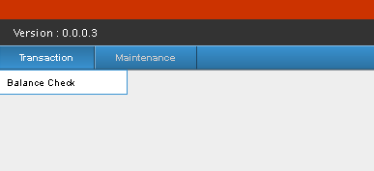
-After clicking, a small menu will appear, which contains, Main control and View.
-Under Main control there are two options; Check Balance and Update Balance, and in View; there is View Transaction.
CHECK BALANCE
Check Balance:
Navigating to Check Balance
-To Check Balance, When you hover your mouse over the transaction tab, a sub-menu will appear beneath, click the balance check.
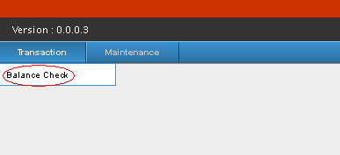
-Under Main Control, press Check Balance.
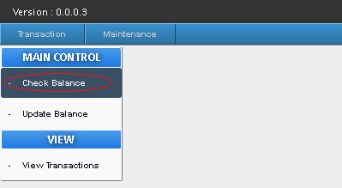
A Check Balance form will appear, The Check Balance form contains; Store, Requested by,Credit Limit, Available Balance.
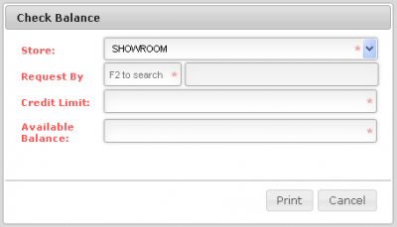

STEP 1:
Pick Desired Store.
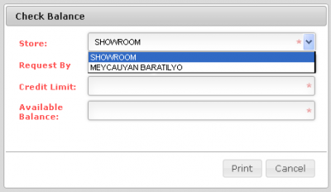
STEP 2:
Click on the requested by textbox, then press F2.
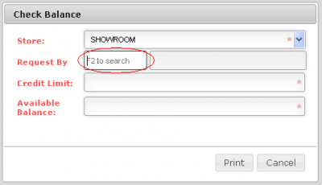

*After Pressing F2 a Search Employee Form will appear.
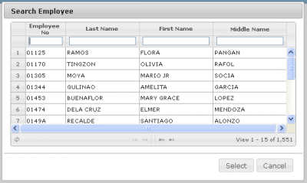
STEP 3:
Search for an Employee.
Using their basic information like, Employee no., Last name, First Name, and Middle Name.
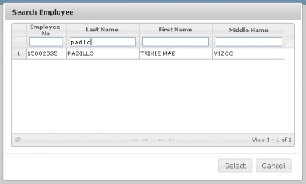

STEP 4:
Click on the Desired Employee and press select or double click.

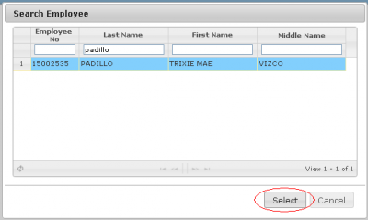
*You will be redirected to the Check Balance form, with the Employee's Credit limit and Available Balance.
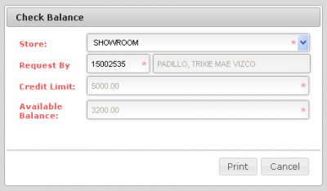

STEP 5:
Press the Print Button.
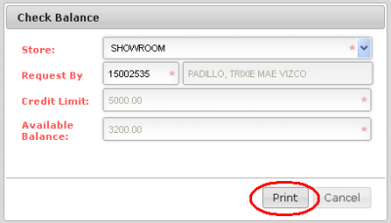

Other Information
*After Pressing the Print button, A Browser Pop-up will appear, it contains a downloadable and printable PDF file.
The PDF file contains the Employee Information, which are; The Date/ Time of the Transaction, Company, Employee No., Complete Name, Department, Credit Limit, and Available Balance.
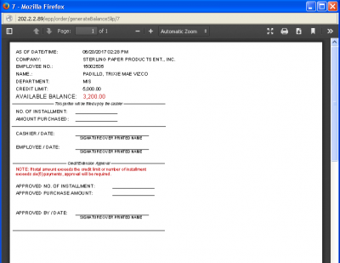
It also contains a small fill-up form, which will be filled up and signed by the cashier, the employee and an Approval form which contains Approved no. of installments, Purchase amount, and approved by whom and signature.
- Approval form only to be filled if total amount exceeds the Credit limit or No. Maximum Installments (6).

UPDATE BALANCE
Navigating to Update Balance
To Update Balance, When you hover your mouse over the transaction tab, a sub-menu will appear beneath, click the balance check.

Under Main Control, press Update Balance.

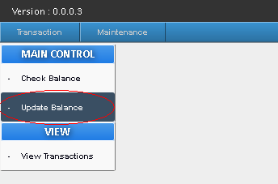

A Serve Order form will appear,the Serve Order form contains; Store, Order by, Transaction date and No., Deduction Code, Total SD Amount, Installment, Payroll Deduction Amount, Credit limit, Available Balance.

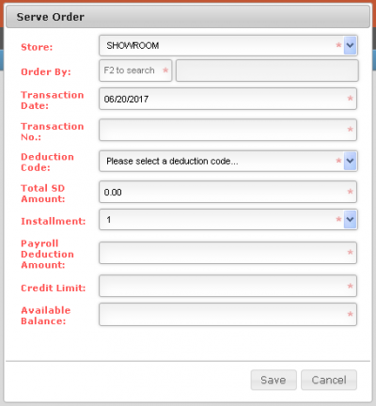

STEP 1:
Choose your desired Store.

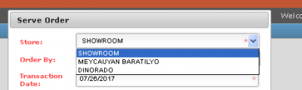

STEP 2:

Click on the Order by Textbox, and Press F2. After
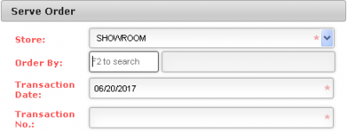
- Pressing F2 a Search Employee Form will appear.
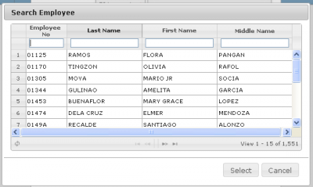

STEP 3:
Search for a Desired Employee, using their basic information like, Employee no., Last name, First Name, and Middle Name.
STEP 4:
Click on the Employee and press select or double click.

Pressing Select, you will be redirected to the Serve Order Form, with the Employee's Credit limit and Available Balance.
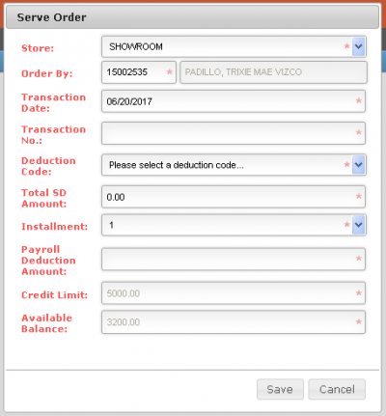
STEP 5:
Enter the desired; Transaction no., The Deduction Code, Total SD Amount, Installment.

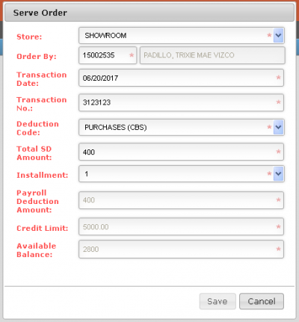
STEP 6:
Press Save.

Other information
- If you entered a Total SD Amount of 500 and below, The installment will automatically be "1"
but you may change the installment to "1 - 6".
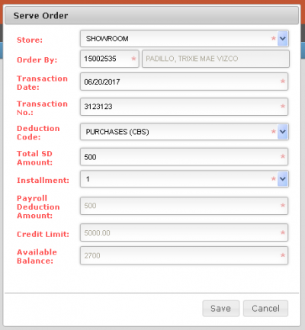
- If you Entered a Total SD Amount of 501 and above, The installment will automatically be "6"
but you may change the installment to "1 - 6".
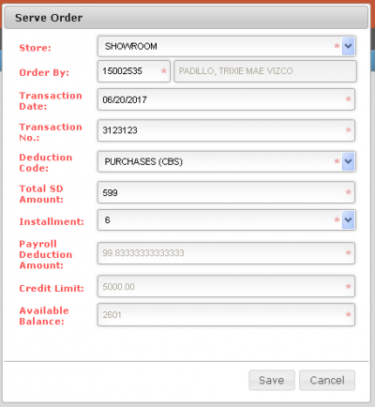
- Exceeding 6 installments, an "is approved, with a check box and an Approver" will appear.
you should check if the documents presented are approved and by whom, and press the check box and select who approved the document and proceed with the transaction.
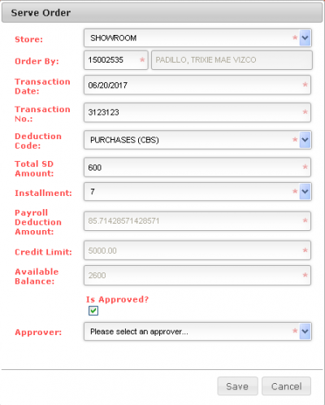
- If the installment is exceeding 6, and the documents is not approved, discontinue the transaction.
- If the Total SD Amount is exceeding Available Balance, A Message box will appear containing a warning,
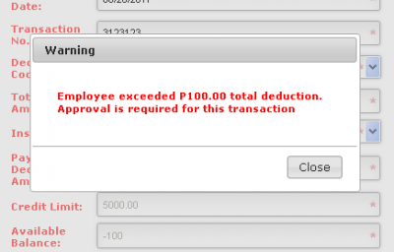
- The Transaction would also need an Approval before continuing Transaction, otherwise Discontinue Transaction.
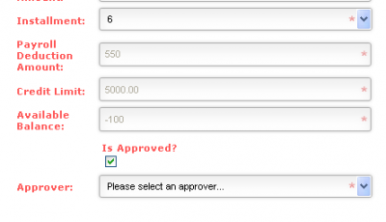
VIEW TRANSACTION
Navigating to View Transaction
-To view transactions that have been made; When you hover your mouse over the transaction tab, a sub-menu will appear beneath, click the balance check.

-After clicking, a small menu will appear, which contains, Main control and View.
-Under view, there is View Transaction, click it
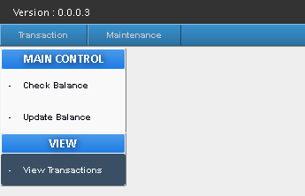
-After clicking you will be redirected to Transaction List page.
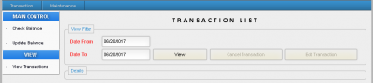

STEP 1:
Enter Date From.
STEP 2:
Enter Date To.
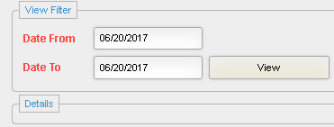
STEP 3:
Click view button.

- details list box, all transaction/s will appear based on a certain span of dates you entered.

Other Information
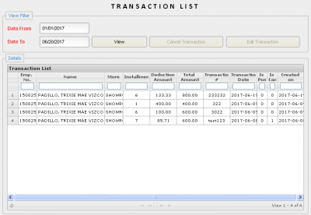
- You may also enter information on the transaction list,to make the list shorter and more specific,
whether its Emp. no., Name, Store, Installment, Deduction Amt., Total, Amt., Transaction no., Transaction Date, Is posted, Is Cancelled, and when was the transaction was created.
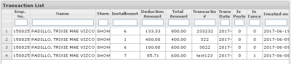

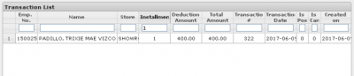
-If you pressed through the results on the Details list box, As long as the "Is Posted", and "Is Cancelled" is set to "0",The Two buttons will be activated. The buttons are; Cancel Transaction, and Edit Transaction.
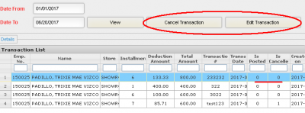
-If any of the "Is Posted" or "Is Cancelled" is set to "1" to any transaction, The the two buttons; Cancel Transaction and Edit Transaction will be Deactivated.
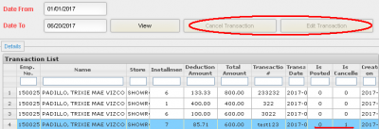

Cancelling a Transaction
STEP 1:
Find the transaction you want to cancel, click it, and press Cancel Transaction Button.
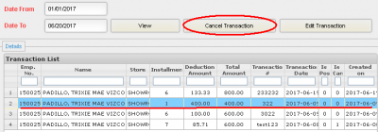
A Message Box will appear containing confirmation.
STEP 2:
Press Yes to continue and No to Cancel Cancellation of transaction.

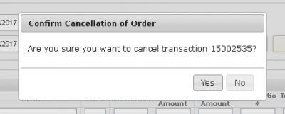

Editing a Transaction
STEP 1:
Find the transaction you want to Edit, click it, and press Edit Transaction Button.

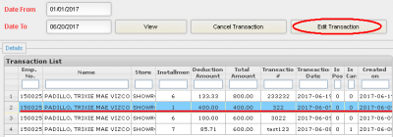
- After Pressing Edit Transaction Button, An "Update Transaction Form" will appear,
STEP 2:
Now edit the Transaction information you want to Edit.
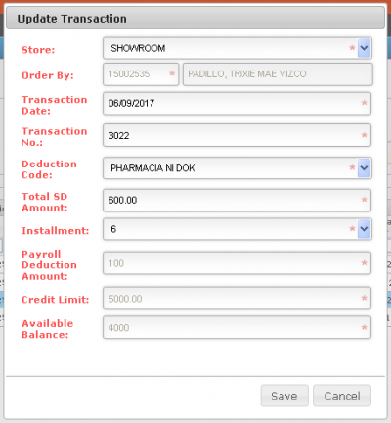

STEP 3:
Press Save.

MAINTENANCE
-After accessing SPGC Employee Electronic Purchase (Admin), you will be redirected to the main view.
-In the Main view, you can see the menu according to your access level. you can see here the version no., transaction and maintenance module, and the currently log user.
-Just hover over the Maintenance tab, by doing that, a sub-menu will appear; you may choose their the options you want to do, it includes; User access, Employee, Employee Batch, Credit Limit Job Level, Credit Limit.
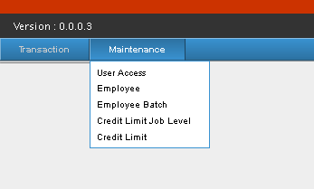

USER ACCESS
User Access Manual
Navigating to User Access
-While you are in the Main view Page, you will see in the Navigation bar are "Transaction" and "Maintenance" ,Hover over the Maintenance Tab, while hovering, a sub-menu will appear, there you click the "User Access" from the sub-menu.
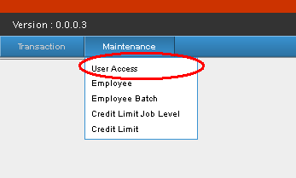
-After clicking User Access, a "User Rights Form" will appear.
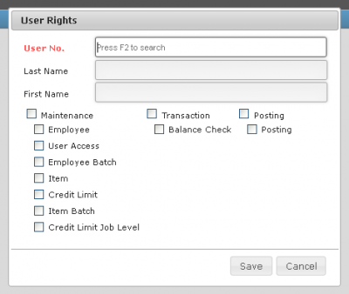

STEP 1:
Click on the "User No. Textbox" and press F2
Pressing F2, a "Search User Form" will appear.
STEP 2:
Search for Employees that have access over E.P.P. After you have selected a certain employee, you will be redirected again to the "User Rights Form" you may now edit their rights over E.P.P.
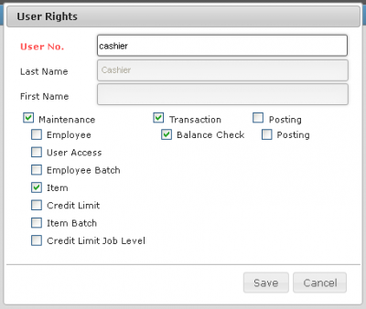
STEP 3:
Change their access over Maintenance, Function and Posting.
STEP 4:
Press Save.

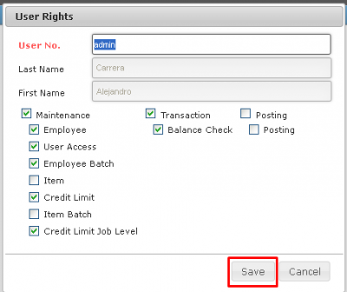

EMPLOYEE TAB
Employee Manual
Navigating to Employee
-While you are in the Main view Page, you will see in the Navigation bar are "Transaction" and "Maintenance" ,Hover over the Maintenance Tab, while hovering, a sub-menu will appear, there you click the "Employee" from the sub-menu.
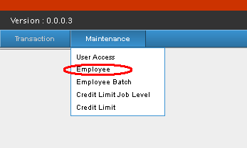
-After clicking Employee, an "Employee Maintenance Form" will appear.
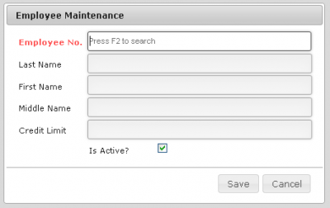

STEP 1:
Click on the "Emp. no. Textbox" and press F2, An "Employee Search Form" will appear.
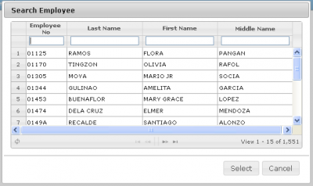
STEP 2:
Search for an employee with their; Emp. no. Last Name, First Name, Middle Name.
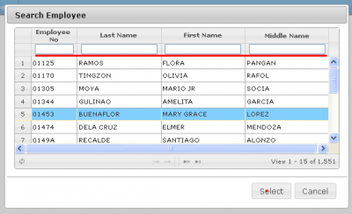
STEP 3:
Click Desired Employee on the list, and press Select.
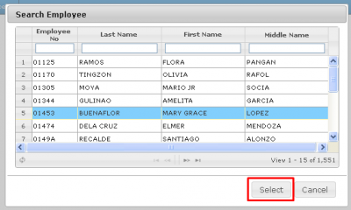
- You will now be redirected to "Employee Maintenance Form", there you will now see the selected Employee's; Emp no. Last/First/Middle name, and their credit limit.
STEP 4:
Edit Employee Information
- You may also edit if the certain Employee is Active or not, by clicking the "Is Active Check box".
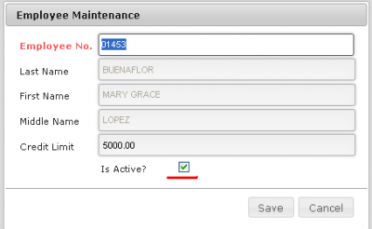
- If the "Is Active Check box" is unchecked, a "Reason Text box" will appear.
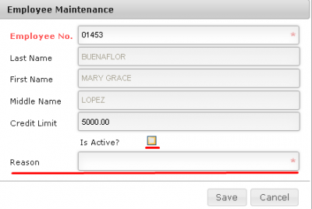
- You can now state the reason why that Employee is not Active.

STEP 5:
Click Save and a Message box will appear asking for your confirmation, click yes to continue.
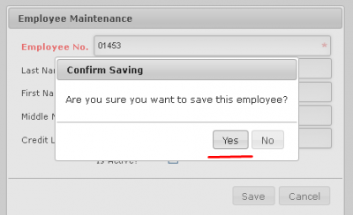
EMPLOYEE BATCH
Employee Batch Manual
Navigating to Employee Batch
-While you are in the Main view Page, you will see in the Navigation bar are "Transaction" and "Maintenance" ,Hover over the Maintenance Tab, while hovering, a sub-menu will appear, there you click the "Employee Batch" from the sub-menu.
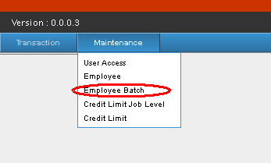
-After clicking Employee Batch, an "Employee Batch Processing Form" will appear.

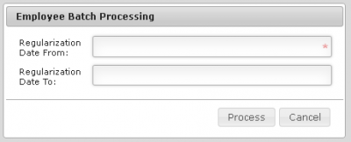

STEP 1:
Enter The Date From, and the Date to
STEP 2:
Click Process.
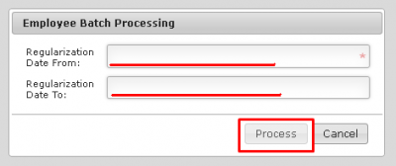

- A Message box containing the confirmation of the process will appear.
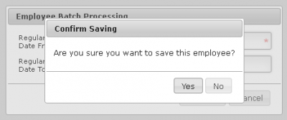
- After pressing yes, another Message box will appear containing on how many Regular Employees have been transferred on the system.
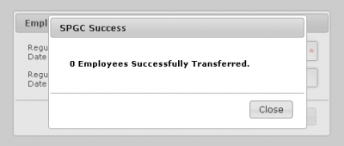
- You have now successfully transferred Regular Employees on that certain date range on the system.

CREDIT LIMIT JOB LEVEL
Credit Limit Job Level Manual
-While you are in the Main view Page, you will see in the Navigation bar are "Transaction" and "Maintenance" ,Hover over the Maintenance Tab, while hovering, a sub-menu will appear, there you click the "Credit Limit Job Level" from the sub-menu.
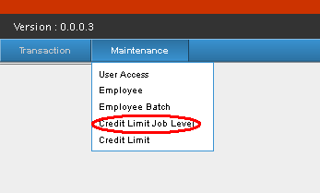
-After clicking Credit Limit Job Level, an "Credit Limit Job Level Form" will appear, containing Job level, and Credit limit.
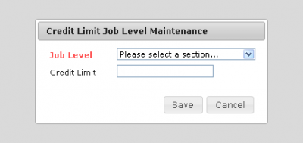
-On that form, you select the job level from the job level drop-down box, click on it, and the Job level will be listed there.
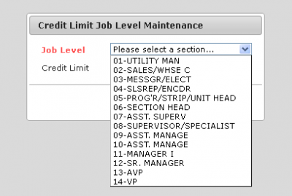
-After selecting the Job Level from the list, the Credit limit of that Job level will appear. Now you may edit or change the Job level's Credit limit, After you have finished editing, you may now press Save button, a Message box will appear containing confirmation of the change, click yes to proceed with the change.
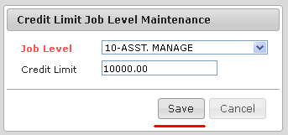
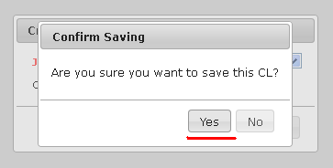
-You have now edited the Job level Credit Limit.

CREDIT LIMIT
Credit Limit Manual
-While you are in the Main view Page, you will see in the Navigation bar are "Transaction" and "Maintenance" ,Hover over the Maintenance Tab, while hovering, a sub-menu will appear, there you click the "Credit Limit" from the sub-menu.
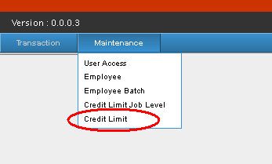
-After clicking Credit Limit, a "Credit Limit Form" will appear, containing Emp. No., Last/First/Middle name, Credit Limit and Reason.

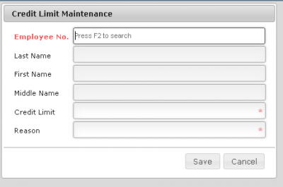
-You may now search for the desired Employee by clicking "Emp. no Text box" and pressing F2 on your keyboard.
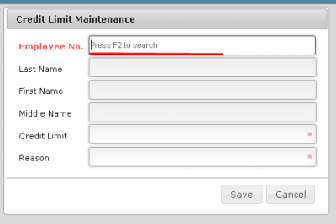
-After pressing F2, a Search Employee Form will appear.
-On this form you may search for an employee with their; Emp. no. Last Name, First Name, Middle Name.
-After you have found the desired Employee, click their name on the list, and press Select.
-You will now be redirected to "Credit Limit Form". There, the desired Employee's information will be added, information like; Emp. no., Last/First/Middle Name, Credit Limit, Reason..
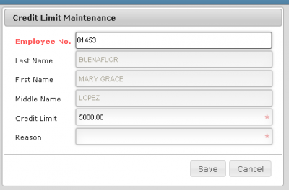
-You may now change the Credit Limit of that certain Employee and state the reason why the Credit Limit was changed.

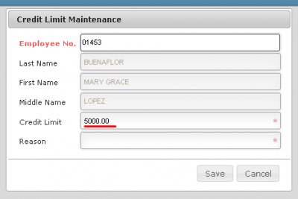
-After you have changed, you can now press save, after pressing save a Message box will containing confirmation of the change, press yes to continue of the saving of the change.
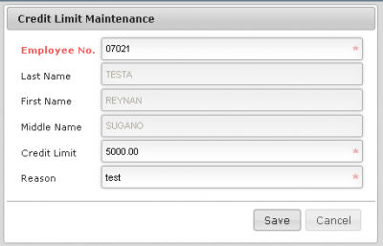
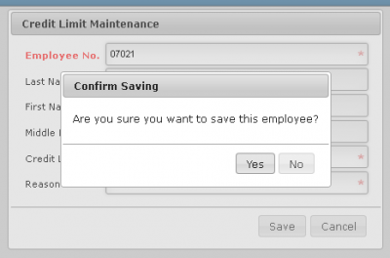
- You have now Successfully changed the Credit limit of that certain Employee.

REPORT
Navigating to Transaction Report
* In the Main view, hover over report tab, click the Transaction Report on the sub-menu.
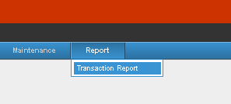

STEP 1:
Select Desired Store.
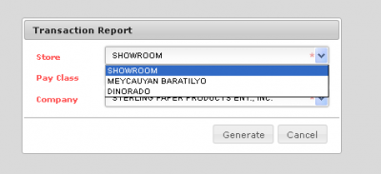
STEP 2:
Select Desired Pay class.
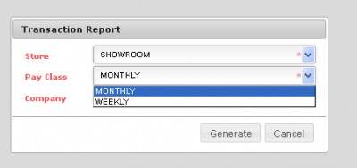
STEP 3:
Select Desired Company.

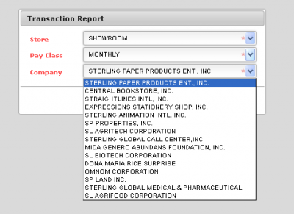

STEP 4:
Press Generate.
