1. **Active RNF – SSS Contribution**

*Select which type of employee information and input on the text box. Click Go Search to generate report.

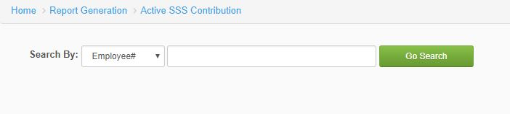

*Figure 1.0*

1. **Active RNF – Pag-ibig Contribution**

* Select which type of employee information and input on the text box. Click Go Search to generate report.

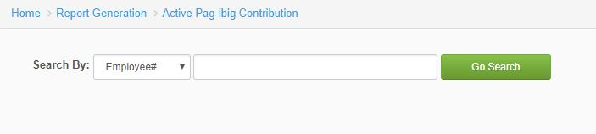

*Figure 2.0*

1. **Active RNF – PhilHealth Contribution**

* Select which type of employee information and input on the text box. Click Go Search to generate report.

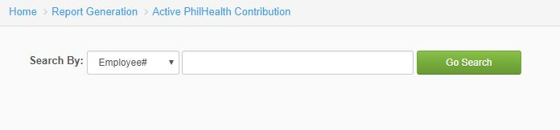

*Figure 3.0*

1. **Separated RNF – SSS Contribution**

* Select which type of employee information and input on the text box. Click Go Search to generate report.

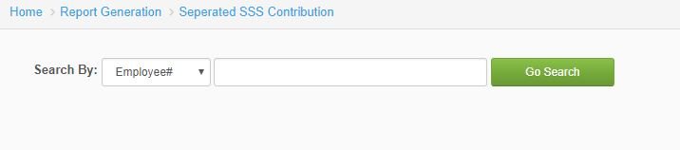

*Figure 4.0*

1. **Separated RNF – Pag-ibig Contribution**

* Select which type of employee information and input on the text box. Click Go Search to generate report.

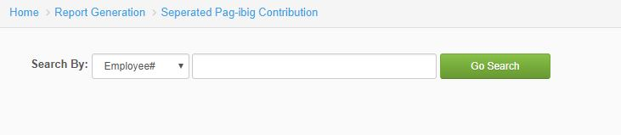

*Figure 5.0*

1. **Separated RNF – PhilHealth Contribution**

* Select which type of employee information and input on the text box. Click Go Search to generate report.

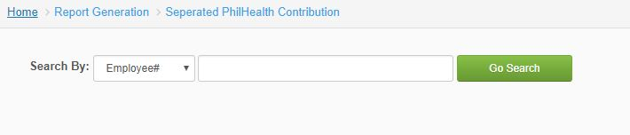 *Figure 6.0*

1. **Active VIP – SSS Contribution**

* Select which type of employee information and input on the text box. Click Go Search to generate report.



*Figure 7.0*

1. **Active VIP- Pag-ibig Contribution**

* Select which type of employee information and input on the text box. Click Go Search to generate report.



*Figure 8.0*

1. **Active VIP – PhilHealth Contribution**

* Select which type of employee information and input on the text box. Click Go Search to generate report.



*Figure 9.0*

1. **Separated VIP – SSS Contribution**

* Select which type of employee information and input on the text box. Click Go Search to generate report.

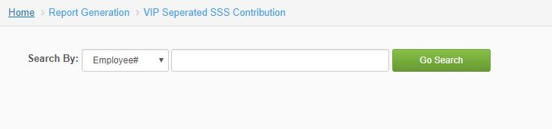

*Figure 10.0*

1. **Separated VIP – Pag-ibig Contribution**

* Select which type of employee information and input on the text box. Click Go Search to generate report.

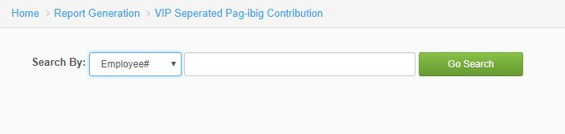

*Figure 11.0*

1. **Separated VIP – PhilHealth Contribution**

* Select which type of employee information and input on the text box. Click Go Search to generate report.

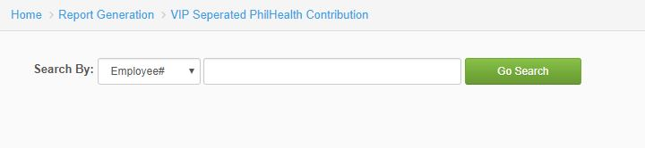

*Figure 12.0*