**Roundcube Maintenance (**[**http://202.2.2.89/myrcutil**](http://202.2.2.89/myrcutil)**)**

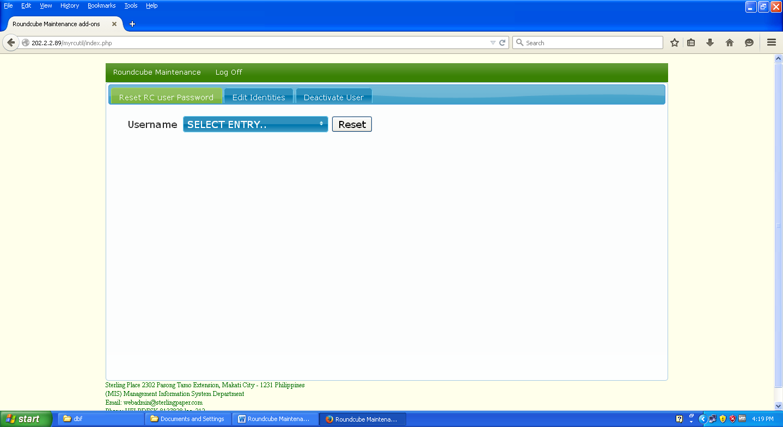

2.2

2.1

5

4

2

1

**FUNCTIONALITY:**

**1 –** To view the data maintenance of the system.

**2 –** To reset the password of an account (initial password: **init1234)**

**2.1** -> Click this drop down button then in the space provided (textbox) 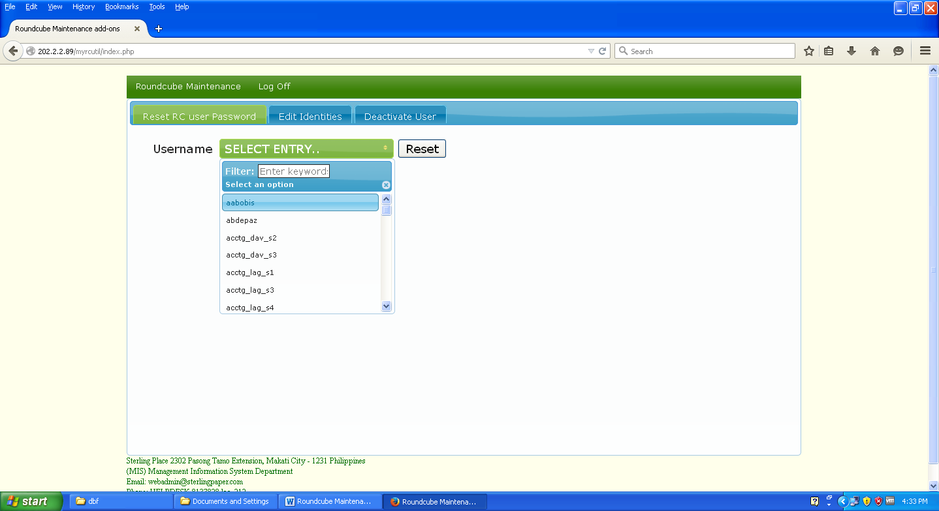input the username of the account you wish to reset.

**2**.**2 ->** Then click this button to finally reset the password. (***Note:*** *A confirmation will display after clicking this button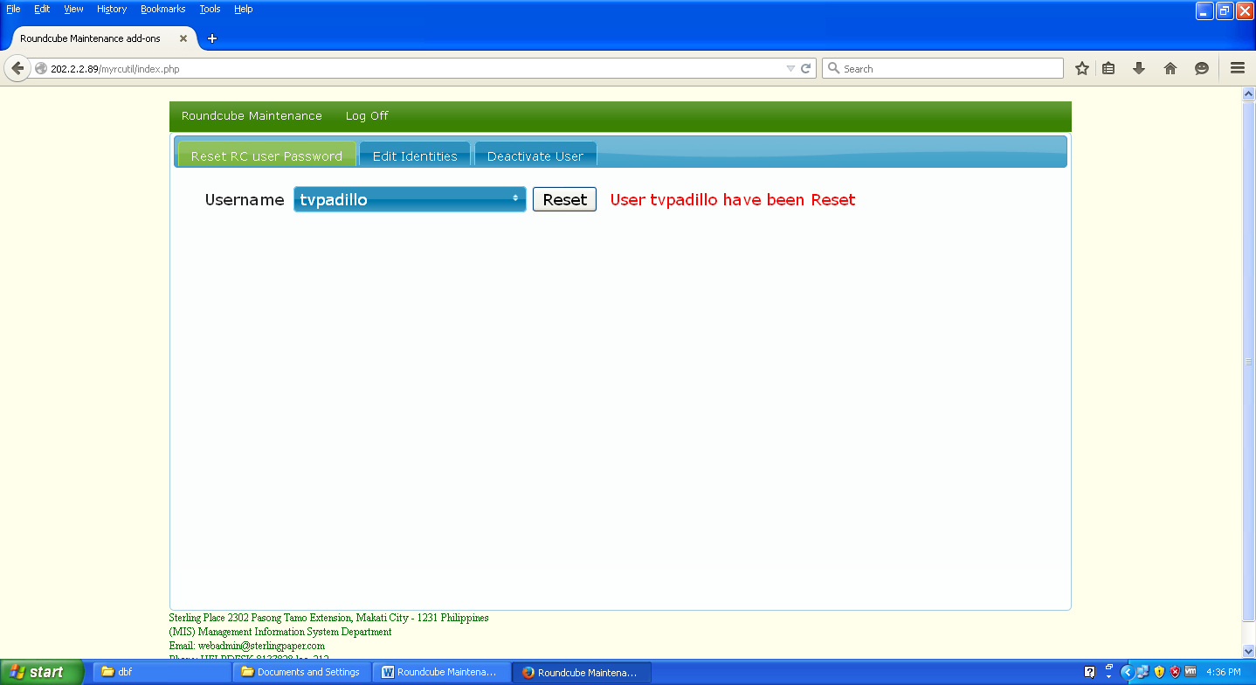.*

**4 –**To edit the identities (Surname,Firstname Middle Name) of an account.

4

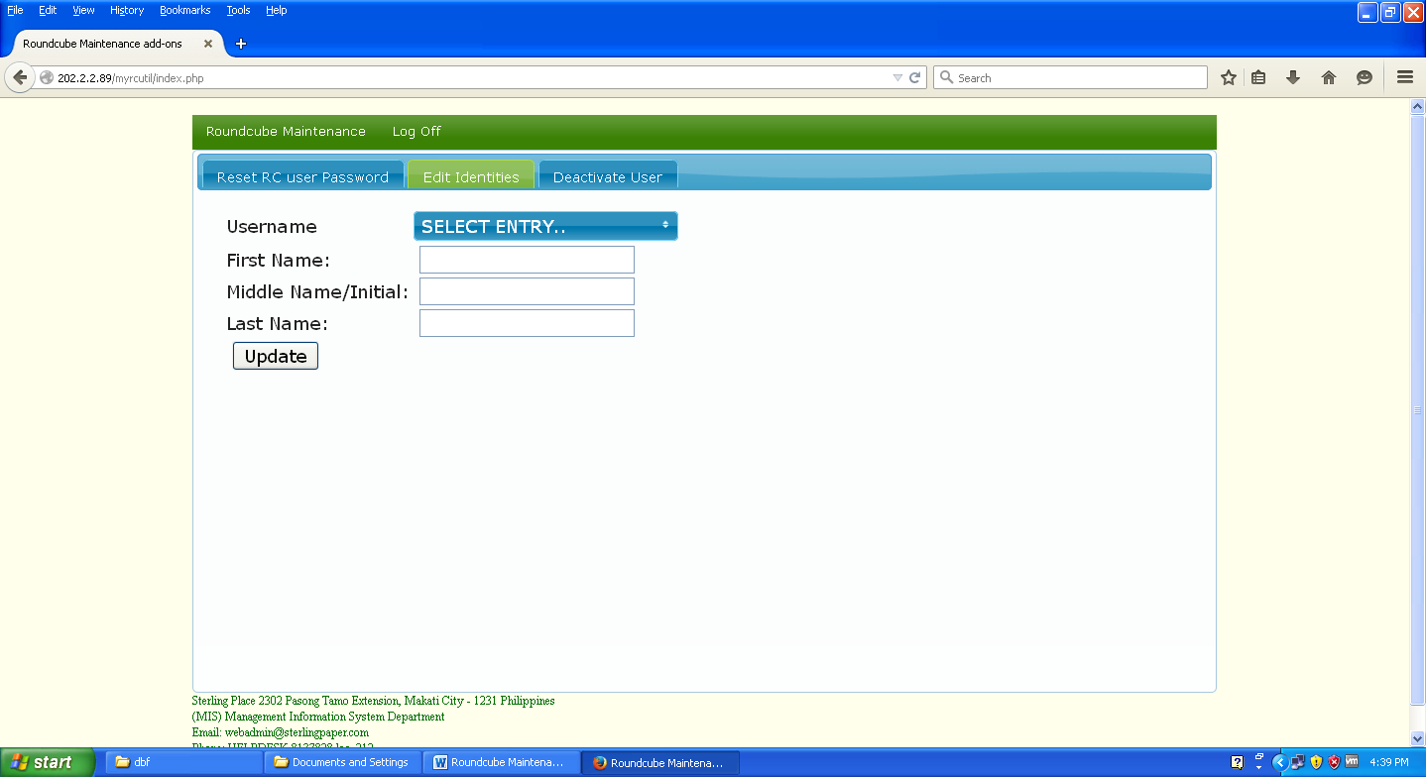

4.3

4.1

4.2

**4.1** -> Click this drop down button then in the space provided (textbox) input the username of the account you wish to update.

**4.1** -> Input the new user’s information.

**4**.**3 ->** Then click this button to finally update the user’s identities. (***Note:*** *A confirmation will display after clicking this button.)*

5

**5 –** To deactivate/delete a user account.

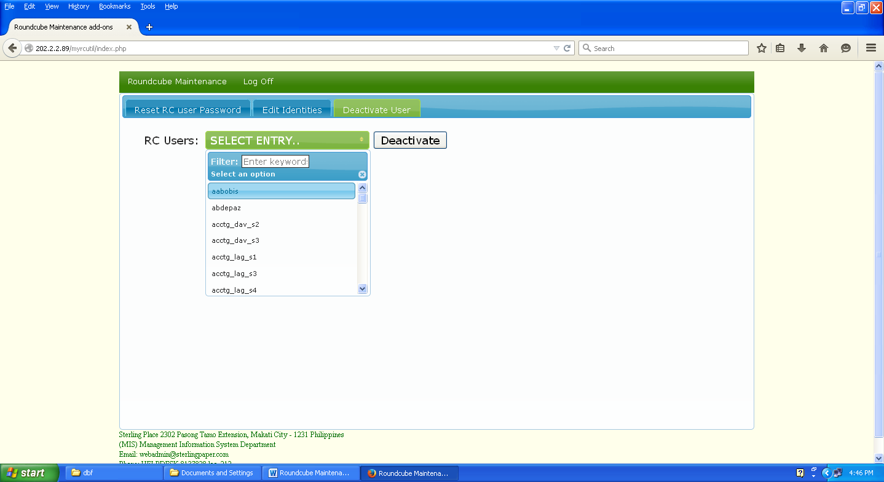

5.2

5.1

**5.1** -> Click this drop down button then in the space provided (textbox) input the username of the account you wish to deactive/delete.

**5**.**2 ->** Then click this button to finally update the user’s identities. (***Note:*** *A confirmation will display after clicking this button.)*