1. **Lastpay Processed**

*In Lastpay Processed, the user will select type of pay class, company, and will input the reference number. Click generate to view reports.

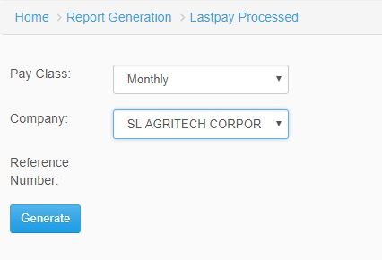

*Figure 1.0*

1. **Computed Lastpay**

*In Computed Lastpay, select type of pay class, company, and input the reference number. Click generate to view the reports.

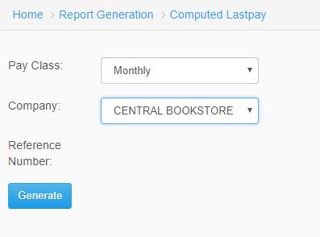

*Figure 2.0*

1. **Lastpay with Remaining**

*In Computer Lastpay with Remaining, select type of pay class, company, and input the reference number. Click generate to view the reports.

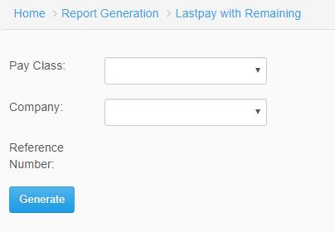

*Figure 3.0*

1. **Computed Lastpay Per Employee**

*In Computed Lastpay Per Employee, input the employee number and reference number. Click Generate to view reports.

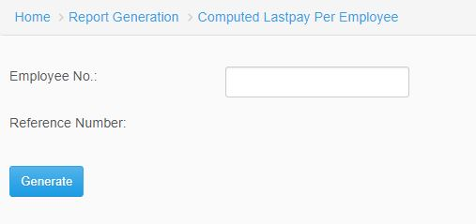

*Figure 4.0*

1. **Lastpay Breakdown**

*In Lastpay Breakdown, select type of pay class, company and input reference number. Click generate to view the reports.

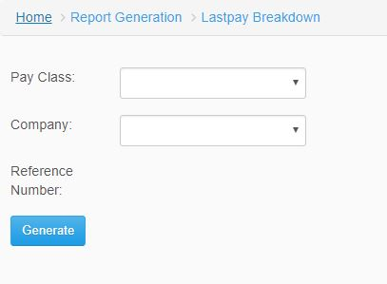

*Figure 5.0*

1. **Lastpay SAP GL**

*In Lastpay SAP GL, select type of pay class, company, and input reference number. Click generate to view the reports.

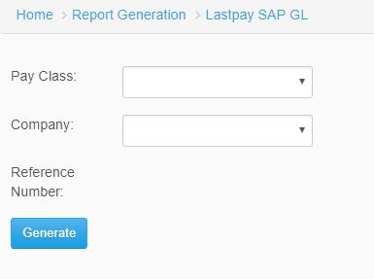

*Figure 6.0*

1. **Lastpay with RD Per Employee**

*In Lastpay with RD Per Employee, Input the employee number and click generate to view the reports.

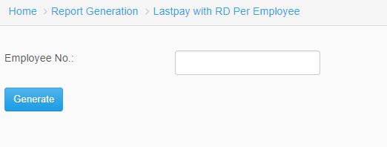

*Figure 7.0*

1. **Lastpay Bank Advice**

*In Lastpay Bank Advice, select pay class, company, and input the settlement code and bank code to view report. Click generate to view report.

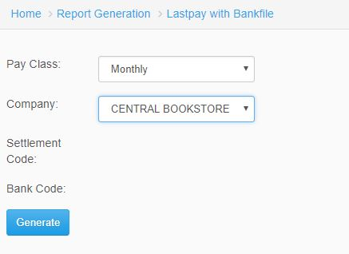

*Figure 8.0*

1. **Lastpay with Bankdisk**

*In Lastpay with Bankdisk, select pay class, company, settlement code, bank code to view report. Click Generate to view reports.

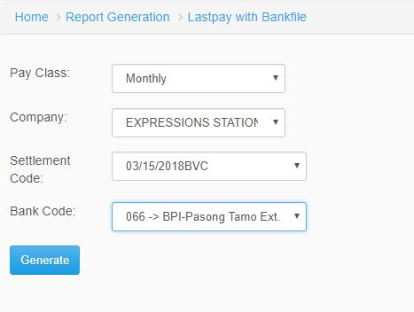

*Figure 9.0*

1. **Lastpay Recon**

*In order to generate report in Lastpay Recon, select type of pay class, company, and input reference number. Click generate to view reports.

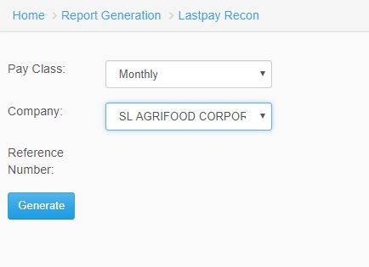

*Figure 10.0*