**Employee Order**

**Navigating to Employee Order**

**\*** In the navigation bar, there is one tab named **Order**. Hover your mouse over it, a sub- menu will appear. Click **Employee Order**.

[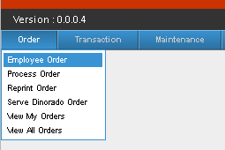](http://202.2.2.89/spgcwiki/index.php/File:Eord.png)

**\***Now a **Employee Ordering Form** will appear. It contains, Store, Employee, Credit Limit, Available Balance.

**STEP 1:**

**\***Click on the Store Combo box, Choose **Dinorado**.

After choosing Dinorado; Item, Qty, Price, and Total Amount will appear.

[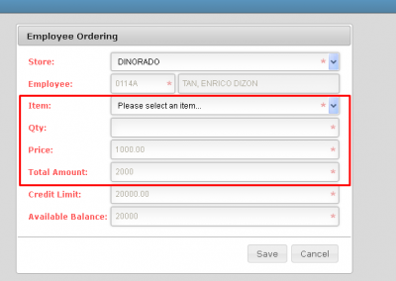](http://202.2.2.89/spgcwiki/index.php/File:Eord1.png)

**STEP 2:**

**\***Choose desired Item. in Item Combo box.

**Willy Dinorado Rice 5Kg** price is 200, while, **Willy Dinorado Rice 25kg** Price is 1000.

**STEP 3:**

**\***Now enter quantity of your Item.

it will also be multiplied to the price, You will see the Total price of your transaction, on **Total Amount textbox**.

**STEP 4:**

Now press Save.

Your transaction will be forwarded to **HR**, HR will now be responsible for your Transaction.

[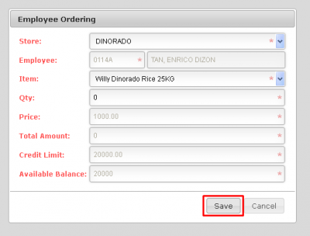](http://202.2.2.89/spgcwiki/index.php/File:Eord2.png)

*If your Total amount will exceed your Credit Limit then, A message box will be containing that you cant continue further because Total Amount exceeded your Credit limit.

[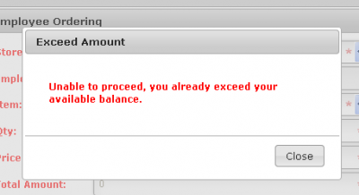](http://202.2.2.89/spgcwiki/index.php/File:Eord3.png)