**CASH-PAYROLL GENERATION OF REPORT (http://202.2.2.51/p/pay/mylogin.php)**

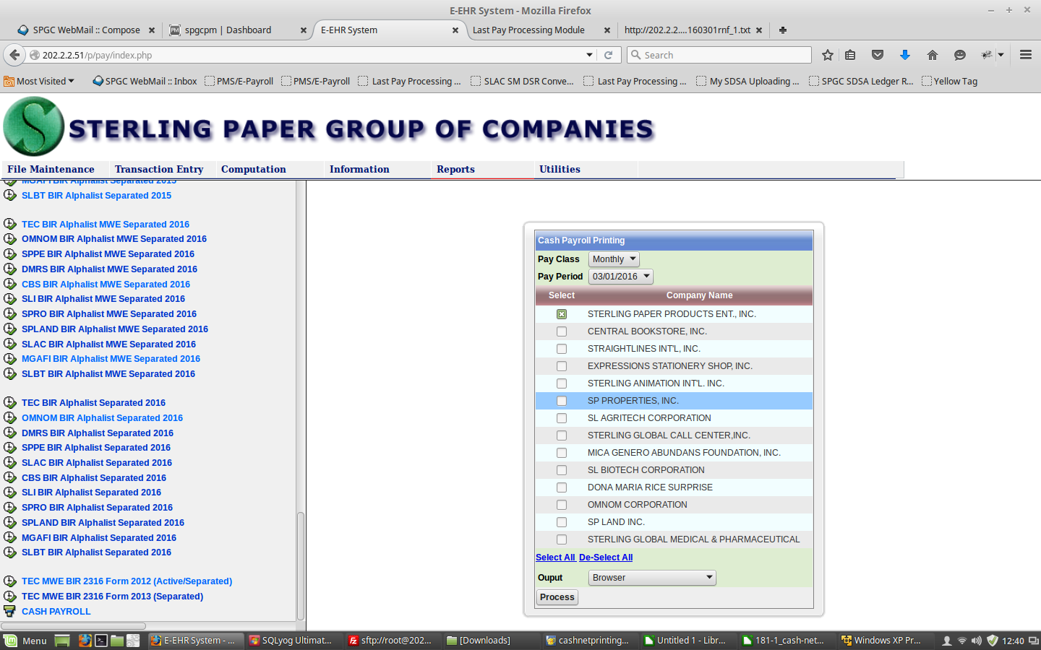

3

4

1

2

**Below are the steps in generating CASH-PAYROLL**:

1. Click **Reports** button.
2. Next click **CASH PAYROLL** link/option.
3. Then select what **Pay Class, Pay Period, Company and Output** you want to generate.
4. And click **Process** button to finally view/generate the CASH-PAYROLL of the specific cut-off.