**Accounting**

1. **Payroll Journal**

*In order to generate Payroll Journal, select the Year, Pay Class, Pay Period, Employment type and the Company of the employee to view the report.

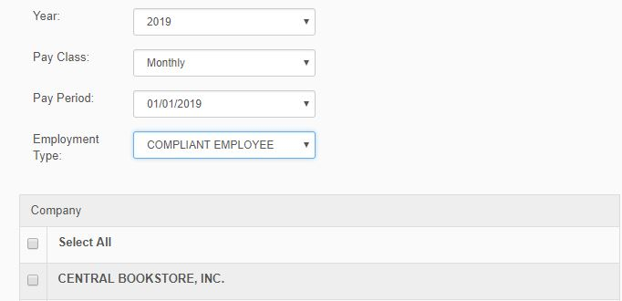

*Figure 1.0*

1. **Year** – In this module the user will input the year of report.

2. **Pay Class** – In this module the user will choose what type of class he/she want to view.

3. **Pay Period –** In this module the user will choose what date he/she want to view.

4. **Employment Type** – In this module the user will choose what type of employee does she belongs.

5. **Company –** The user will choose which company the employee works.

1. **Payroll Journal Per Department**

*In order the view the Payroll Journal Per Department, select what type of Company, Year, Pay Class, Pay Period, and Department where the employee working and click proc*ess button* to proceed in the reports.

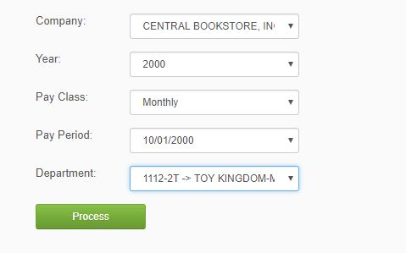

*Figure 2.0*

1. **Company** – In this module the user will select the company.

2. **Year** – In this module the user will choose what year he/she want to process.

3. **Pay Class –** In this module the user will choose what type of Payment.

4. **Pay Period** – In this module the user will choose what date of pay.

5. **Department –** The user will choose what department does the employee working.

1. **Payroll Journal Per Employee**

**\***In order to select Payroll Journal Per Employee, you need to select company of the employee, year, pay class, pay period and department, click process button to generate the report.

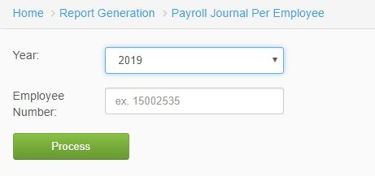

*Figure 3.0*

1. **Company** – In this module the user will select the company of the employee.
2. **Year** – In this module the user will select what year he/she want to generate.
3. **Pay Class** – In this module the user will select type of pay class.
4. **Pay Period** – In this module the user will select the pay period.
5. **Department** – In this module the user will select what department is the employee.
6. **Payroll Reconciliation**

**\***In Payroll Reconciliation, the user will input the year, type, pay class, month, and the list of companies you want to generate report.

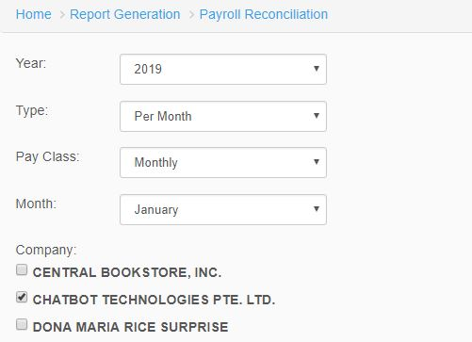

*Figure 4.0*

1. **Year** – In this module the user will select what year he/she want to generate.
2. **Type** – In this module the user will select the type of payment.
3. **Pay** **Class** – In this module is the type of payment to the employee.
4. **Month** – In this module user will select the month of the report.
5. **Company** – In this module companies are listed and select where the employees working.
6. **Sanitized Payroll Per Company**

*In order to view Sanitized Payroll Per Company, you will select year, from, to, company and the location of the employee to and click process button to generate the report.

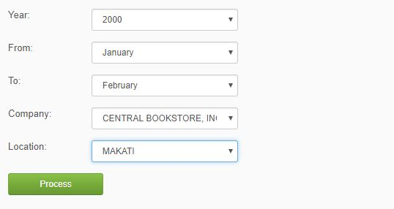

*Figure 5.0*

1. **Year** – In this module the user will select what year he/she want to generate.
2. **From** – In this module the user will select the month where it starts.
3. **To** – In this module the user will select where the month ends.
4. **Company** – In this module companies are listed and select where the employees working.
5. **Location**– In this module the user will choose where the company is located.
6. **Monthly Recap Earning and Deduction (Detailed)**

*In Monthly Recap Earning and Deduction, the user should select the year, pay class, period out, pay period and the company of the employee to generate the report.

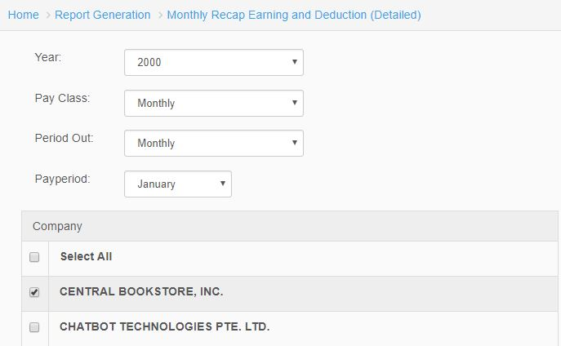

*Figure 6.0*

1. **Year** – In this module the user will select what year he/she want to generate.
2. **Pay** **Class** – In this module is the type of payment to the employee.
3. **Period** **Out** – In this module the user will select when the employee out.
4. **Pay** **Period** – In this module the user will select the pay period.
5. **Company** – Lists of Companies where the employee belongs.
6. **List of Cash Salaries**

*In List of Cash Salaries, the user will input the year, pay class, pay period and select what type of company to generate report.

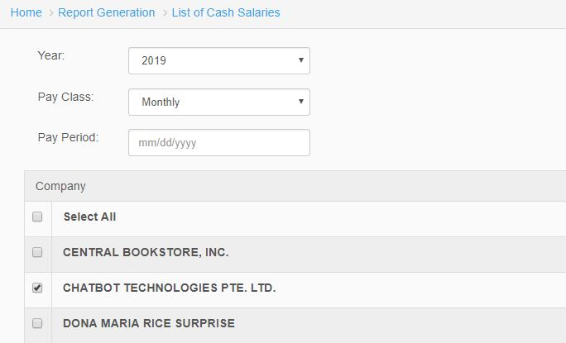

*Figure 7.0*

1. **Year** – In this module the user will select what year he/she want to generate.
2. **Pay** **Class** – The user selects the type of payment in this module.
3. **Pay** **Period** – In this module the user will select the pay period.
4. **Company** – Lists of Companies in SPGC where the employee works.
5. **List of Hold Employee Salaries**

**\***In List of Hold Employee Salaries, the user will select the year, pay class, pay period and company where the employee is working to view the reports.



*Figure 8.0*

1. **Year** – In this module the user will select what year he/she want to generate.
2. **Pay** **Class** – The user selects the type of payment in this module.
3. **Pay** **Period** – In this module the user will select the pay period.
4. **Company** – Lists of Companies in SPGC where the employee works.
5. **List of Pay Slip**

*In List of Pay Slip, the user select year, pay class and input the pay period also select companies to generate the report.

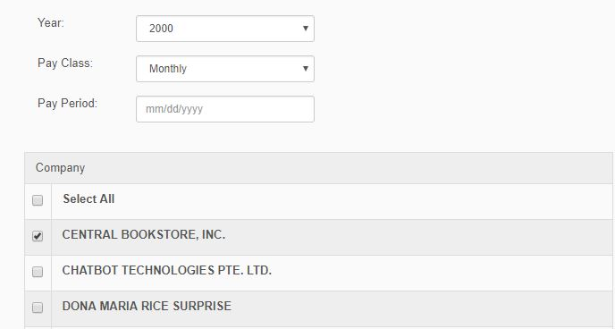

*Figure 9.0*

1. **Year** – In this module the user will select what year he/she want to generate.
2. **Pay** **Class** – The user selects the type of payment in this module.
3. **Pay** **Period** – In this module the user will select the pay period.
4. **Company** – Lists of Companies in SPGC where the employee works.
5. **Detailed Summary of Withholding Tax**

*In Detailed Summary of Withholding Tax, the user will select pay class, year, month, input the cost-center and choose which type of company the employee works, and click process button to generate report.

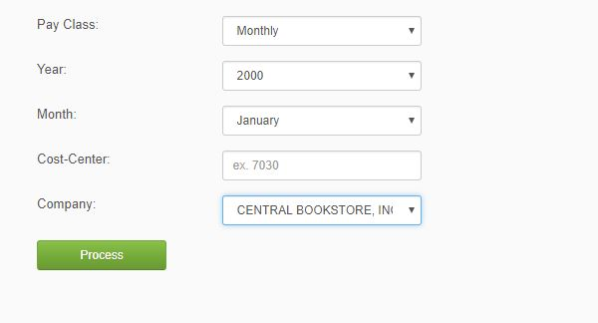

*Figure 10.0*

1. **Pay** **Class** – The user selects the type of payment in this module.
2. **Year** – In this module the user will select what year he/she want to generate.
3. **Month** – In this module user will select the month of the report.
4. **Cost-Center** – In this module the user will input the cost-center to generate report.
5. **Company** – The user will choose which company the employee works.

**XI. Consolidated 13th Month Accrual**

*In Consolidated 13th Month Accrual, you will choose what year, month and company where the employee works.

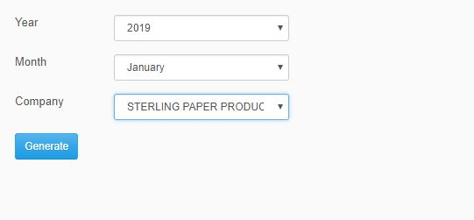

*Figure 11.0*

1. **Year** – In this module the user will select what year he/she want to generate.
2. **Month** – In this module user will select the month of the report.
3. **Company** – The user will choose which company the employee works.
4. **Epp Posted**

*In EPP Posted the user will select what year, company, pay class and pay period to generate the report.

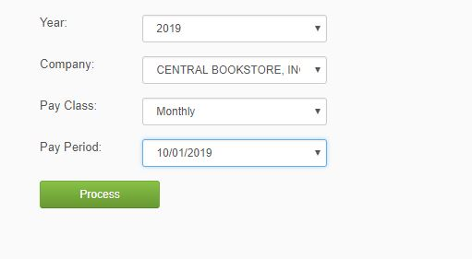

*Figure 12.0*

1. Year – In this module the user will select what year he/she want to generate.
2. Company – In this module the user will choose which company the employee works.
3. Pay Class – The user selects the type of payment in this module.
4. Pay Period – In this module the user will select the pay period.
5. **Open Items**

*In Open Items, the user will choose what year and company, and will input the GL code to generate the separated and active employees.

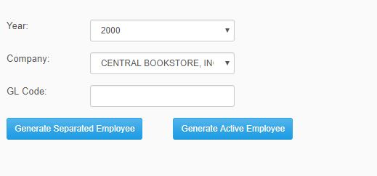

*Figure 13.0*

1. Year – In this module the user will select what year he/she want to generate.
2. Company – In this module the user will choose which company the employee works.
3. GL Code – In this module the user will input the code of the employee to generate active or separated employee.