' **QUOTABASE WEEKLY PROCESS FLOW**

[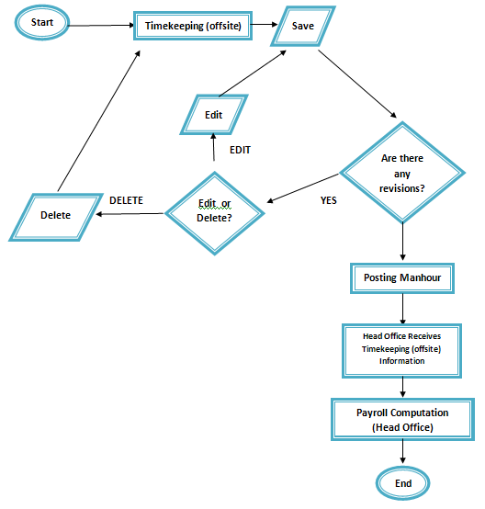](http://202.2.2.89/spgcwiki/index.php/File:Timeoff14.png)

**TIMEKEEPING**

**\*NAVIGATING TO TIMEKEEPING\***

**\***In Timekeeping, in its sub-menu click timekeeping.

[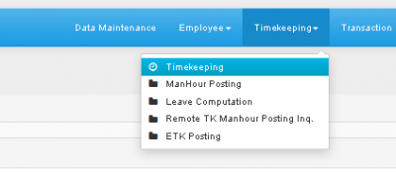](http://202.2.2.89/spgcwiki/index.php/File:Timeoff.png)

**\***You will now be redirected to Timekeeping(Employee Master).

Step 1: Enter Name or Emp No. of desired Employee, then press Search(The Magnifying Glass logo button)

[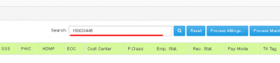](http://202.2.2.89/spgcwiki/index.php/File:Timeoff1.png)

Step 2: Click the Employee No. of your choice to view/update their information.

[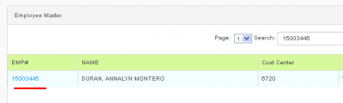](http://202.2.2.89/spgcwiki/index.php/File:Timeoff2.png)

* You will be redirected here.

[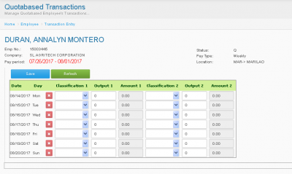](http://202.2.2.89/spgcwiki/index.php/File:Timeoff3.png)

Step 3: Add information using the combo boxes & Textboxes.

[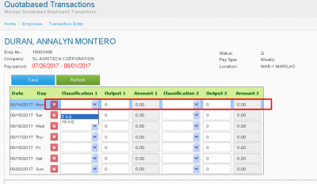](http://202.2.2.89/spgcwiki/index.php/File:Timeoff4.png)

Step 4: Press **Save** if done.

[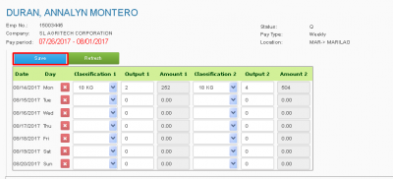](http://202.2.2.89/spgcwiki/index.php/File:Timeoff5.png)

*You can also delete or edit added information.

*Press save then refresh. You may now click the (X) logo to delete that row or edit it by inputting a different information.

[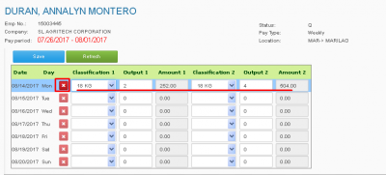](http://202.2.2.89/spgcwiki/index.php/File:Timeoff6.png)

**MANHOUR POSTING**

**NAVIGATING TO MANHOUR POSTING**

**\***In Timekeeping tab, press **Manhour Posting**

[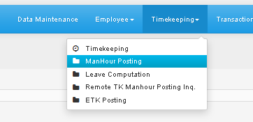](http://202.2.2.89/spgcwiki/index.php/File:Timeoff7.png)

Step 1: In Pay Class Pick, Quotabase Weekly.

[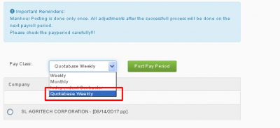](http://202.2.2.89/spgcwiki/index.php/File:Timeoff8.png)

Step 2: Choose Company (SL AGRITECH CORP.)

[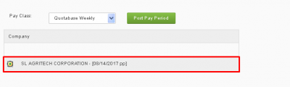](http://202.2.2.89/spgcwiki/index.php/File:Timeoff9.png)

Step 3: Press **Post Pay Period** button.

**PAYROLL COMPUTATION**

**NAVIGATING TO PAYROLL COMPUTATION**

**\*** In Processing Tab, Click Payroll COmputation.

[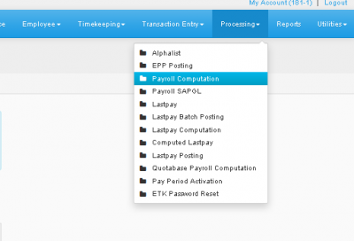](http://202.2.2.89/spgcwiki/index.php/File:Timeoff10.png)

Step 1: Choose Pay Class (Quotabased Weekly)

[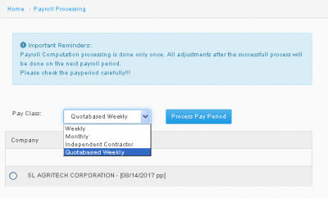](http://202.2.2.89/spgcwiki/index.php/File:Timeoff11.png)

Step 2: Choose Company (SL AGRITECH CORP.)

[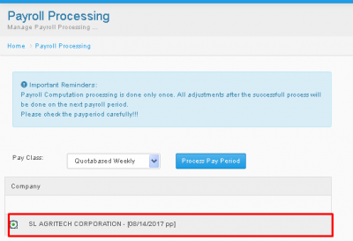](http://202.2.2.89/spgcwiki/index.php/File:Timeoff12.png)

Step 3: Press **Process Pay Period**.

**QUOTABASE ENTRIES**

**NAVIGATING TO QUOTABASE ENTRIES**

In Reports tab, click Quotabase Entries.

[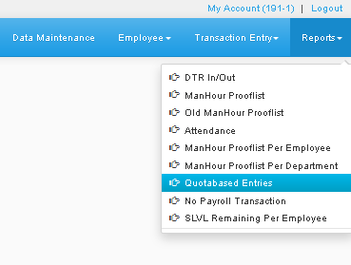](http://202.2.2.89/spgcwiki/index.php/File:Timeoff15.png)

Step 1: Enter desired information using the combo boxes

[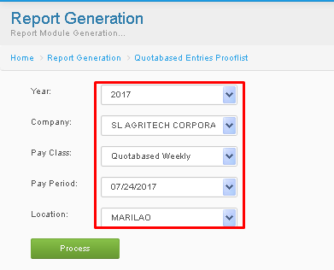](http://202.2.2.89/spgcwiki/index.php/File:Timeoff16.png)

Step 2: Press **Process**

[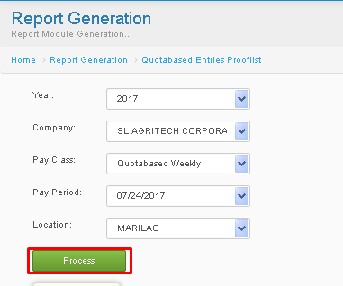](http://202.2.2.89/spgcwiki/index.php/File:Timeoff17.png)

* after pressing process, the results will appear below.

Step 3: Print or Export it to Excel, By clicking **click here to print** or **Click here to export to MS-Excel**.

[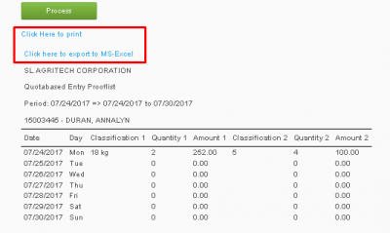](http://202.2.2.89/spgcwiki/index.php/File:Timeoff18.png)