1. **SDSA Encoding Per Date**

*In SDSA Encoding Per Date, the user will input the start encoding date and the end encoding date to view report. Click process button to generate report.

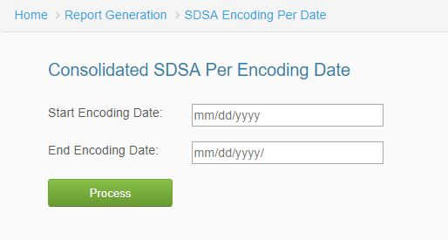

*Figure 1.0*

1. **SDSA Encoding Per Code**

*To view SDSA Encoding Per Code, the user will input the SDSA Code, and select which type of inquiry. Click process button to generate report.

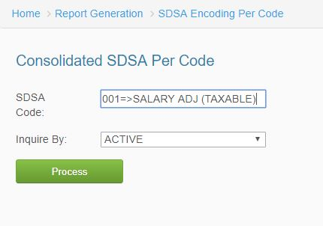

*Figure 2.0*

1. **SDSA Applied Deduction**

*In SDSA Applied Deduction, the user will select the year, company, options, month, input SDSA Code, and inquiry to view applied deduction. Click process button to generate report.

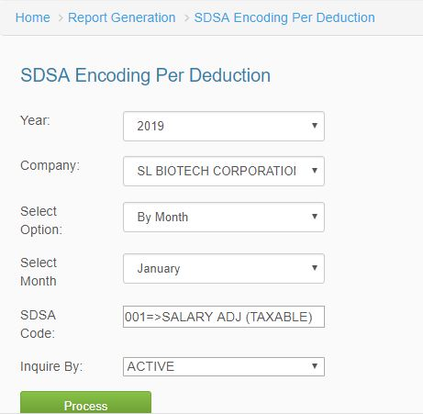

*Figure 3.0*

1. **SDSA Applied Deduction – SLAC**

*In SDSA Applied Deduction – SLAC, select the year, company, select option, month, input SDSA Code, and select inquiry by to view report. Click process button to generate report.

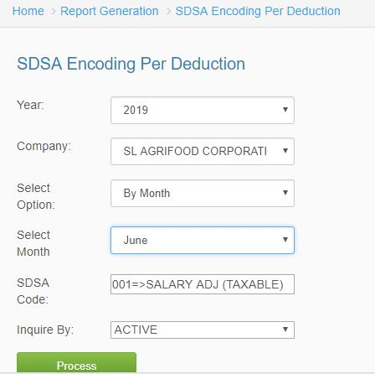

*Figure 4.0*

1. **SDSA Monthly Report**

*In SDSA Monthly Report, the user will select the year, select option, month, and the status. Click process button to generate report.

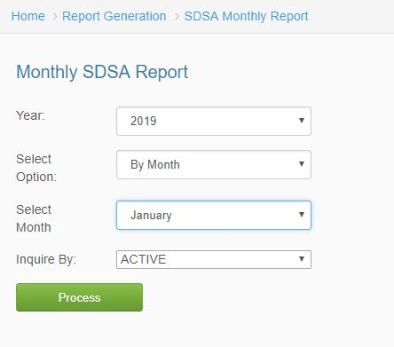

*Figure 5.0*

1. **SDSA Ledger**

*In SDSA Ledger, select the year, pay class, pay period, company to view report. Click Process/Process SDSA Applied to generate report the user wants to view.

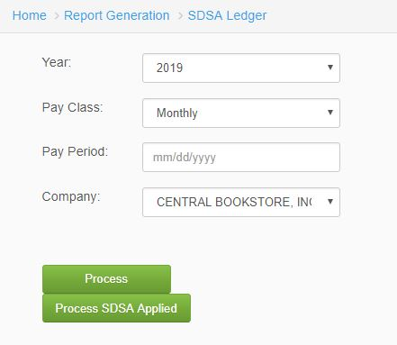

*Figure 6.0*

1. **SDSA Ledger – SLAC**

*In SDSA Ledger – SLAC, select the year, pay class, pay period, and company. Click the *process button* to generate reports.

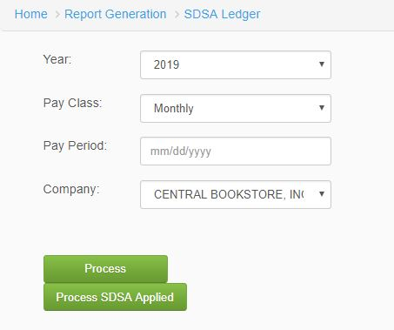

*Figure 7.0*