1. **Employee/Employer Contribution**

*In Employee/Employer Contribution, the user will select the type of pay class, optn perd, year, month optn, company and click generate button to view the reports.

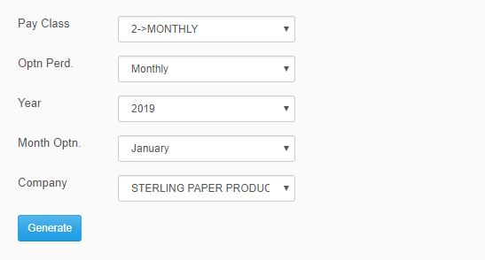

*Figure 1.0*

1. **SSS and HDMF Loan Summary**

*In SSS and HDMF Loan Summary, the user will input pay class, year, month optn, company and click generate button to view the reports.

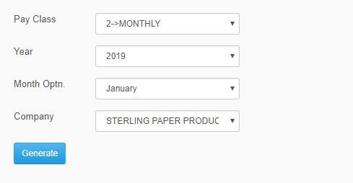

*Figure 2.0*

1. **EPF**

*In EPF, the user will select which type of pay class, year, month, company, file type and click process button to generate button the reports.

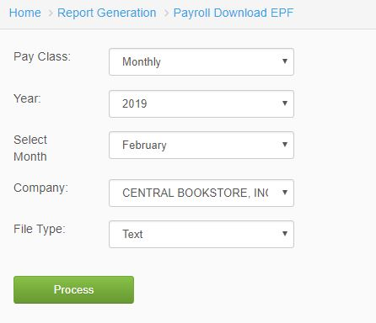

*Figure 3.0*

1. **MCL**

*In MCL, the user will select pay class, year, month, company, file type and by clicking process button it will generate the reports.

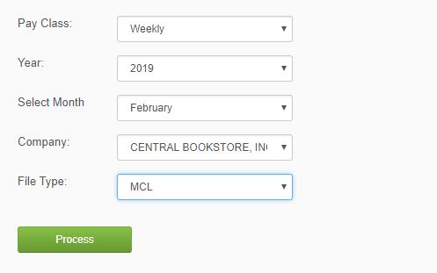

*Figure 4.0*

1. **NEW SSS FORMAT**

*In order to generate the new sss format, the user will select the pay class, year, month, company and file type.

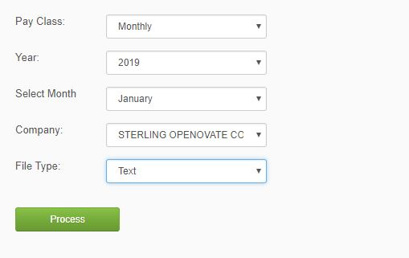

*Figure 5.0*

1. **SSS Loan**

*In SSS Loan, the user will select type of pay class, year, month, company, file type and click process button to generate report.

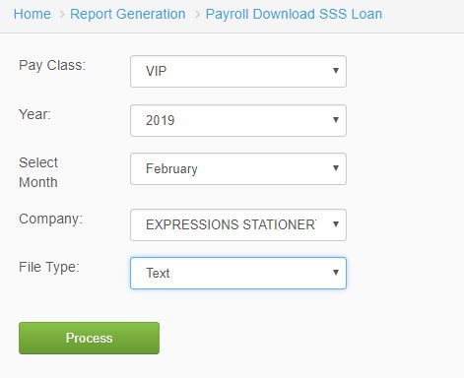

*Figure 6.0*

1. **SLAC SSS**

*In SLAC SSS, the user will select the year and month to view report. Click process button to generate report.

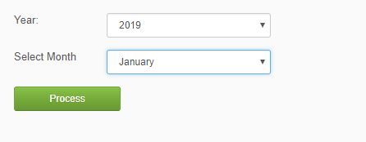

*Figure 7.0*

1. **HDMF Contribution**

*In HDMF Contribution, the user will select the type of pay class, year, month, company and file type. Click process button to generate report.

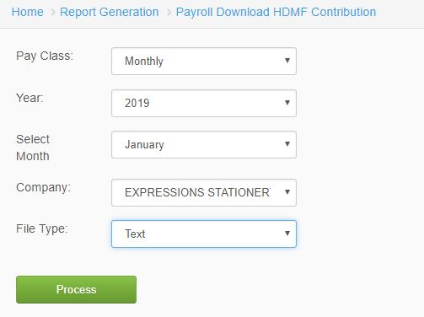

*Figure 8.0*

1. **HDMF Loan**

*In HDMF Loan, the user will select the type of pay class, year, month, company, and file type. Click process button to generate report.

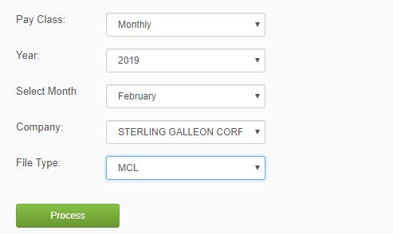

*Figure 9.0*

1. **Simul HDMF Contribution**

*In Simul HDMF Contribution, the user will select the type of pay class, year, month, company and file type to view report. Click Process button to generate report.

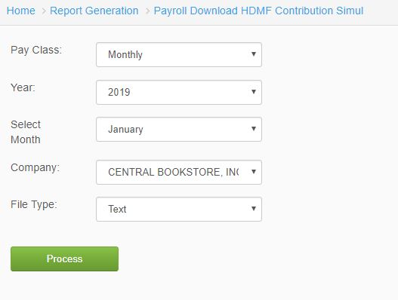

*Figure 10.0*

1. **Tec HDMF Loan Seq**

*In order to view report of Tec HDMF Loan Seq, the user will select the type of pay class, year, month, company, file type. Click process button to generate report.

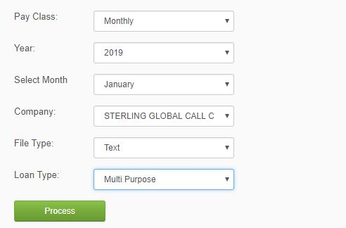

*Figure 11.0*

1. **PhilHealth**

*To view PhilHealth report, the user will input the type of pay class, year, month, company, and file type. Click process button to generate report.

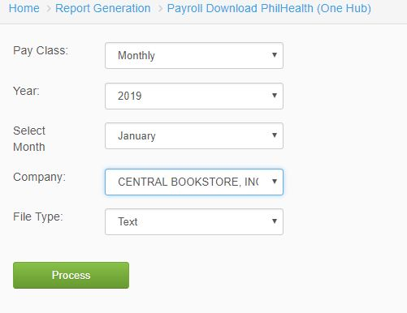

*Figure 12.0*

1. **New PhilHealth Format**

*In order to view New PhilHealth Format, the user will select the pay class, year, month, company, and file type. Click process button to generate the report.

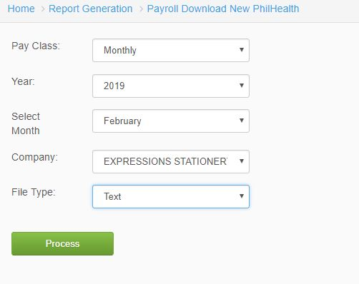

*Figure 13.0*

1. **Taxes Payable (BIR-Internet) with 13th Accrual**

*In Taxes Payable, the user will select the year, month, company and option to view report. Click process button to generate report.

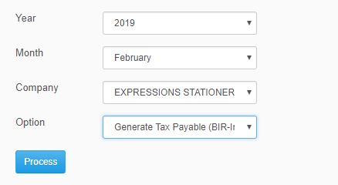

*Figure 14.0*

1. **Monthly Taxes Withheld on Compensation**

*In Monthly Taxes Withheld on Compensation, the user will select the year, month, company of the employee to view report. Click process button to generate report.

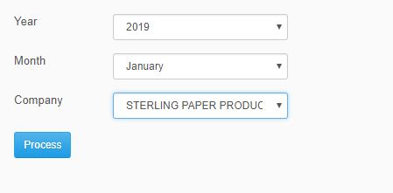

*Figure 15.0*